HRTF 3D
Version 1.1.0

Welcome

Thank you for downloading this fine plug-in from the Delphi ASIO & VST Project. The HRTF 3D plugin convolves the incoming audio with the selected head related transfer function to create the impression of a sound coming from that direction.

In order to get the most out of the HRTF 3D, please spend a few moments reading this brief manual.

License

HRTF 3D has a very simple license:

- HRTF 3D is freeware. This means that you are free to distribute it, give it to friends, or otherwise share it around. However, only the entire unaltered archive, including this document, may be re-distributed.
- Copyright of the code and the finished plug-in remain the property of Delphi ASIO & VST Project and namely the HRTF 3D 's author, Christian W. Budde.
- This plug-in is provided at no cost; therefore the author and Delphi ASIO & VST Project assume no responsibility for any negative effects that may occur to the end user or the equipment used to run the plug-in.
- Magazine editors are welcome to include the plug-in on cover mount discs or similar media; however, we request that a member of the Delphi ASIO & VST Project team be informed via e-mail. A few copies of the publication are always appreciated, but not expected.

Controls

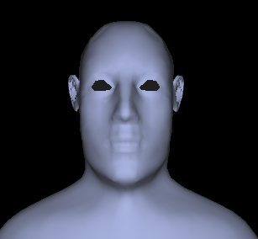
Controlling this plugin is very easy. Just move the head in the desired position to the source. By holding [Ctrl] and [Alt] you can keep either the azimuth or polar direction unchanged.

Feedback / Bug Reports
We are always eager to hear feedback or have bugs reported.

Version History

    - First release!

Credits
• Programming: Christian W. Budde
• Documentation based on a template by Greg Pettit

VST name and technology © Steinberg GmbH
The VST logo is a trademark of Steinberg GmbH

